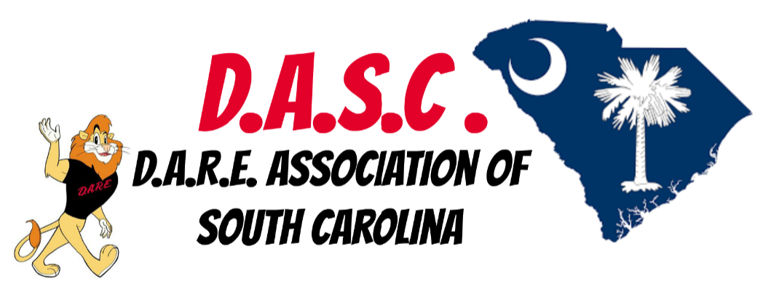
Greetings,
I am writing to you on behalf of the D.A.R.E. Association of South Carolina. The mission of our association is to promote and facilitate training and communication between children, parents, families, schools and officers. We also dedicate ourselves to providing a safe and nurturing learning environment for the students and staff in our school communities throughout the state of South Carolina.
I want to share with you an advertising and sponsorship opportunity with the D.A.R.E. Association of South Carolina Annual Training. We know that your business or organization is commuted to giving back to the community and we would appreciate your consideration to assist our organization. You can do so by making a monetary donation, purchase ad space for our brochure, or to be a sponsor for this year’s training.
Approximately 600 school resource officers across the state are currently protecting schools from violence and intruders. Of those 600 officers we have 157 currently teaching the D.A.R.E. program to our students. Our association’s mission is to ensure that these officers have access to the latest training to maintain the highest level of safety to all those they are sworn to protect and serve. While, these officers first priority is to provide a safe environment for our children we also teach stress management, bully prevention, violence prevention as well as decision making processes. We feel the best way to prevent violence is to educate our students on how to prevent, avoid and remove themselves from these possible situations.
In order for us to provide continued training to our association of officers we need help from community partners like you. If you, your business or organization would like to make a donation to our association, be a sponsor for any of our events and or have your business advertised on our association website and in our annual brochure you can either make that in person or by mail to:
D.A.R.E. Association of South Carolina
P.O. Box 24491
Columbia, SC 29224
SC DARE Association Federal Tax# 81-1453333

ADVERTISING AND SPONSORING INFORMATION
To advertise your business on our website (www.scdare.net) please chose from the following options. This will also include advertisement on our association website for one year.

Business Card $25
Half Page $50
Full Page $100.00

Sponsorship Levels: Website & Banner

Gold $1000.00
Includes- Banner with company name and logo, advertisement on the D.A.R.E. Association of South Carolina website
Silver $750.00
Includes- Sign with your company name and logo, advertisement on the D.A.R.E. Association of South Carolina website
Bronze $500.00
Includes- Advertisement on the D.A.R.E. Association of South Carolina website.

Thank you for your time and consideration in helping our association continue to carry out the mission of providing safe schools and knowledge to our children through the state.

